Photo Guide

**Print quality**

When including photos to demonstrate the print quality of 3D printed parts, make sure that any areas including text and small detailed elements are displayed clearly. Make sure there is enough contrast between the text and the surface it is printed on.

Good Example:

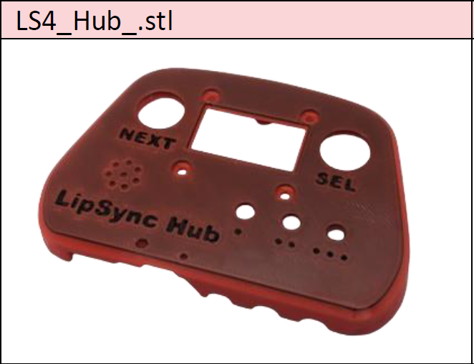 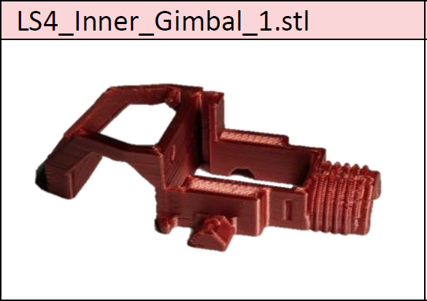

Bad Example:

**Part photos**

When including photos and images for parts, make sure that the

Good Example:

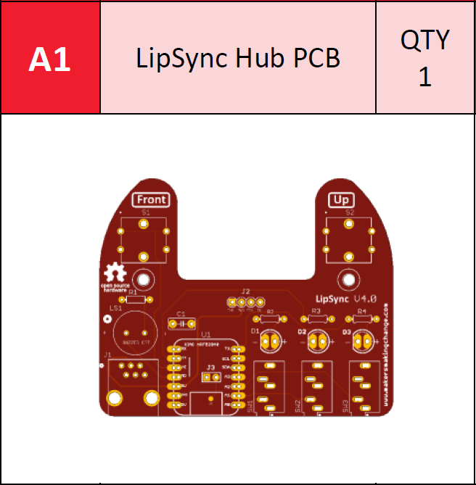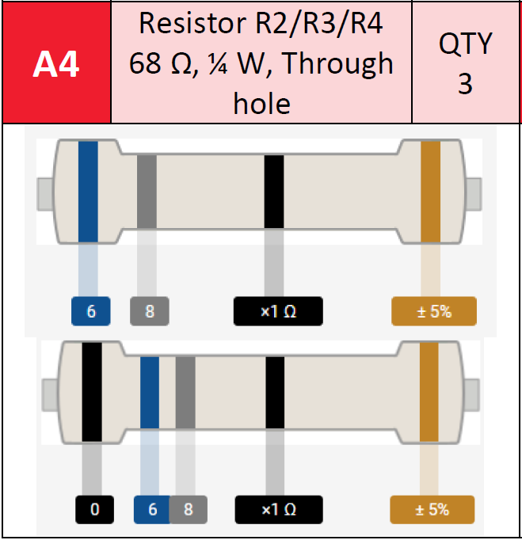

Bad Example:

**Assembly photos**

Good Example:

Bad Example:

**Device photos**

Good Example:

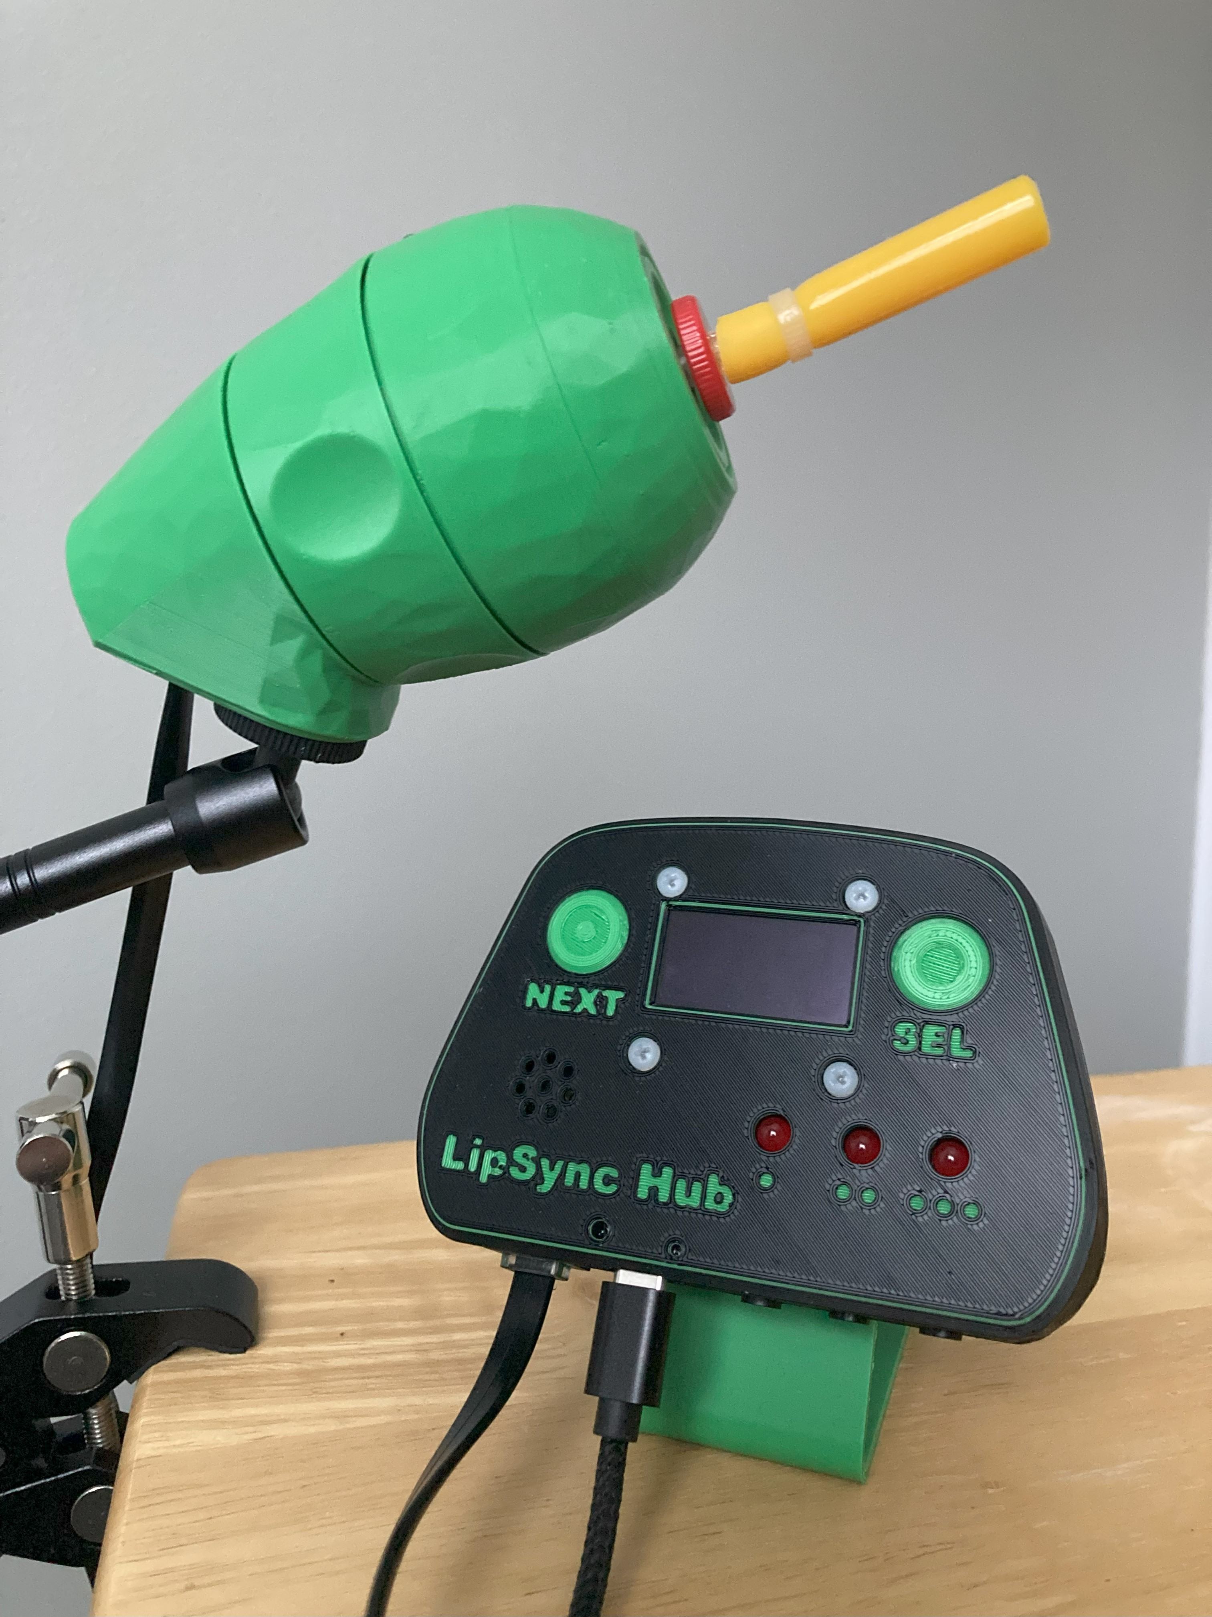 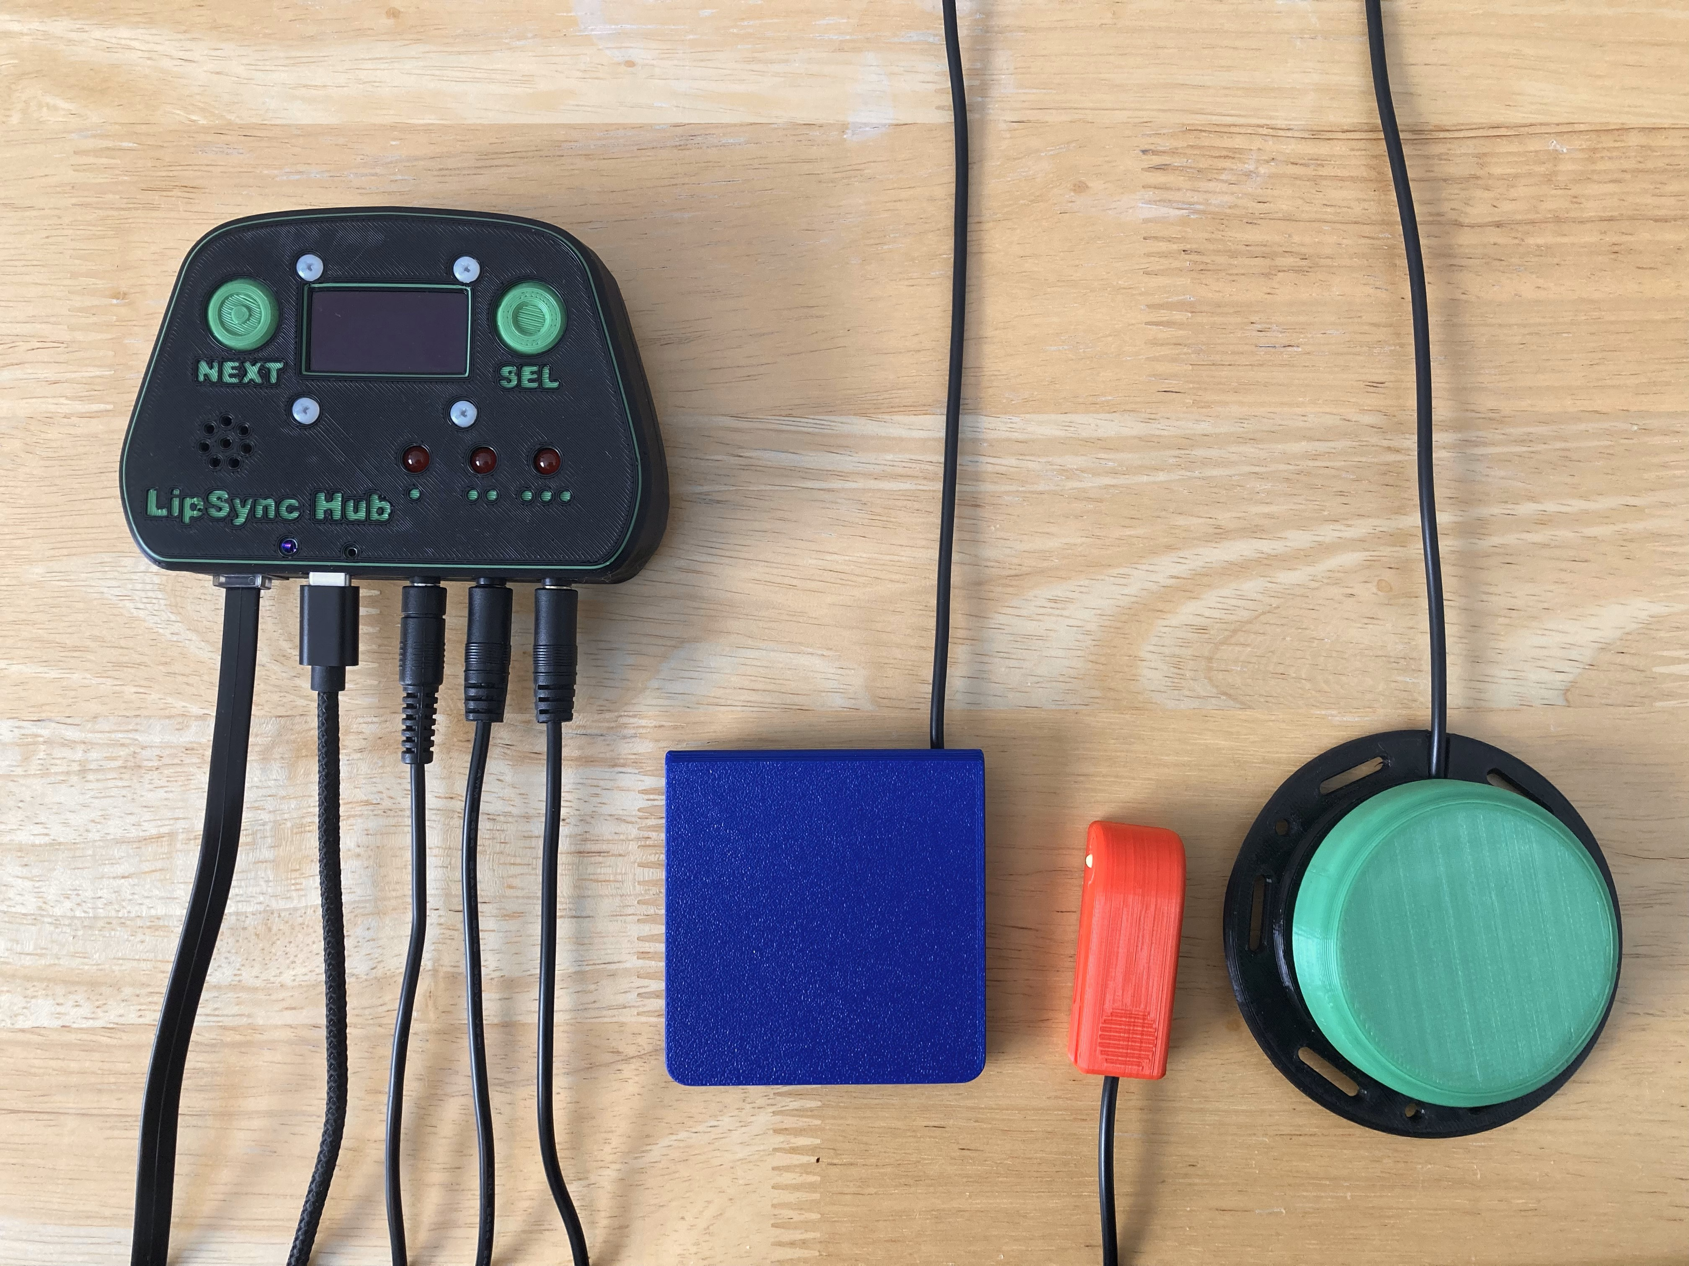

Bad Example: